***ACTION TO PROTECT YOURSELF FROM COVID-19***

***KEEP YOUR TEAM AND THE AIR FORCE HEALTHY***

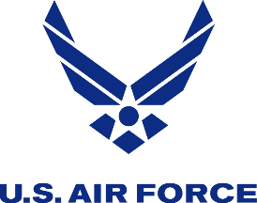

**What to Look For/How to Self-Monitor**

* Fever - Shortness of breath
* Chills - Difficulty breathing
* Cough - Body aches
* Fatigue - Loss of smell/taste
* Diarrhea

- Symptoms typically appear 2-14 days after exposure to the virus or an infected person.

- Some people do not develop symptoms, but can still spread the virus.

**How Does COVID-19 Spread?**

- Between people who are in close contact with one another (within about 6 feet).

- Through respiratory droplets when an infected person coughs, sneezes or talks.

- Possibly though touching contaminated surfaces and touching your eyes, mouth, nose.

**How To Stop COVID-19**

**Wash your hands** often, with soap and water for 20 seconds or >60% alcohol hand sanitizer, especially after being in public, coughing, sneezing, or blowing your nose.

**Avoid touching** your eyes, nose and mouth with unwashed hands.

**Avoid close contact** with people; stay at least 6 feet apart (about 2 arms length).

**Avoid contact** with people who are sick, even household members when possible.

**Cover your mouth and nose with a cloth face covering** when around others

**Don’t share** personal items.

**Clean frequently** touched surfaces.

**Monitor your health/symptoms**, especially after close contact with others.

**What To Do If You Feel Ill**

**Isolate yourself** at home/or a location away from other people

**Contact a healthcare provider** for what to do next (call ahead first if not an emergency) (702)-653-CARE

**Inform** your supervisor and/or commander

**Continue to monitor** your symptoms

**Seek Emergency Medical Attention if** you have or see the following signs or symptoms: trouble breathing, constant pain/pressure in your chest, inability to stay awake, bluish lips or face

